# A review of infant cry analysis and classification

There were a total of 1,389 infant cry samples (1,049 normal and 340 asphyxiated) in the Chillanto dataset.

<https://link.springer.com/article/10.1186/s13636-021-00197-5/tables/1>

1. Dunstan baby language:

What is Dunstan  
<https://www.babytaal.nl/media/PDF/ComprehensiveBooklet(2).pdf>

Dunstan video

<https://www.dailymotion.com/video/x6x8u5z> part1

<https://www.dailymotion.com/video/x6x8ub3> part2

How they use dunstan baby language

<https://iopscience.iop.org/article/10.1088/1742-6596/1528/1/012019/pdf>

1. Baby Chillanto (2004)  
   <http://www.ece.ualberta.ca/~reyesgal/infantcry/> password user4675
2. Donate a cry dataset  
   <https://github.com/gveres/donateacry-corpus>
3. SPLANN  
    Paper used SPLANN
   1. [**https://eudl.eu/pdf/10.1007/978-3-319-92213-3_37**](https://eudl.eu/pdf/10.1007/978-3-319-92213-3_37) **“This database contains five types of cries (eructation, discomfort, hunger, pain, colic)”**
   2. <https://sci-hub.se/downloads/2019-08-23/6b/tuduce2019.pdf?rand=6133441771b48?download=true>  
      **It contains 7 types of baby cries: colic, eructation, discomfort, hunger, pain, pathology, and tiredness, obtained from 136 different babies: a total of 13373 real-world baby cries**
   3. http://www.softwinresearch.ro/index.php/en/research-projects/splann
4. <https://sci-hub.se/10.1109/sped.2015.7343077>

Self recorded dataset

<https://www.ncbi.nlm.nih.gov/pmc/articles/PMC8222524/#B27>

The dataset of pain, hunger, and sleepiness cries was collected from the infants born in National Taiwan University Hospital Yunlin Branch, Taiwan

*Correspondence: P. M. Durai Raj Vincent [pmvincent@vit.ac.in](mailto:pmvincent@vit.ac.in)

Chuan-Yu Chang [chuanyu@yuntech.edu.tw](mailto:chuanyu@yuntech.edu.tw)

Paid dataset <https://www.pond5.com/search?kw=baby-crying&media=sfx>

Dunstan papers: [motaz.saad@gmail.com](mailto:motaz.saad@gmail.com)

1. <https://iopscience.iop.org/article/10.1088/1742-6596/1528/1/012019/pdf> Email **:** [**chan@cs.ui.ac.id**](mailto:chan@cs.ui.ac.id)

“In order to obtain only the clear sound of babies’ cry, the video file is cut and converted into some audio files with “wav” format, 16000 Hz sample rate, mono audio channel, and maximum duration-1 second length for each cry sound. The extracted infant’s cry sound audio consists of 315 in total, each of which represents 56 “neh” sounds, 106 “owh” sounds, 55 “eh” sounds, 61 “heh” sounds, and 37 “eairh” sounds”

1. <https://sci-hub.se/10.1109/tsp.2018.8441412>   
   **Email:** [**monica.dascalu@upb.ro**](mailto:monica.dascalu@upb.ro)

The database consists of 315 audio files recorded at 16 kbps, with maximum 1 second length. Each file is the audio recording of a baby’s utterance corresponding to one of the five “Dunstan words”. The files are audio captures extracted by the authors, from the video materials released by Priscilla Dunstan, available on the Internet. The materials were recorded in studio conditions, without noises, echoes, etc. The labeling (classification) of the “words” was done by Dunstan herself or other Dunstan certified personnel. The audio captures do not require any other post-recording filtering. The data set contains an equal number of recordings for each “word”: “neh”, “eh”, “owh”, “eairh”, “heh”. 250 files (50 for each class) were used for the CNN training and 65 files were used for testing (13 for each class).

Step 1

Our target dataset

| dataset | State (downloadable, need extraction, need to contact | size | Labels / categories | Links |
| --- | --- | --- | --- | --- |
| Dunstan baby language | Done |  | Hungry, sleepy, burping, belly pain, discomfort | <https://www.dailymotion.com/video/x6x8u5z> part1  <https://www.dailymotion.com/video/x6x8ub3> part2 |
| Baby Chillanto | downloadable | deaf 858, asphyxia 340, normal 507, hunger 350,  pain 192 | Asphyxia, Deaf, Hungry, Normal, Pain | <http://www.ece.ualberta.ca/~reyesgal/infantcry/> password user4675 |
| Donate A Cry | downloadable | belly pain 16, burping 8, discomfort 27,  hungry 382, tired 24 | Hungry, sleepy, burping, belly pain, discomfort | https://github.com/gveres/donateacry-corpus |
| SPLANN (2015)  تم التواصل | need to contact | belly pain 225, burping 505, discomfort 2210,  hungry 5536, pain 4404, pathology 459, tired 34 | Hungry,  burping,  belly pain, discomfort,  Pain,  Tired,  pathology | <https://sci-hub.se/10.1109/sped.2015.7343077> |
| Self-recorded database (2019)  Recorded by first-time parents | waiting | hungry 6263, sleepy 4927,  wet diaper 3056, pain 5445 | Hungry,  Sleepy,  wet diaper , pain | <https://link.springer.com/chapter/10.1007%2F978-3-030-15035-8_76> |
| Self-recorded database (2016) Collected from National Taiwan University Hospital | waiting | hungry 586, pain 723, sleepy 860, |  | <https://sci-hub.se/downloads/2019-03-22/1d/10.1109@JAS.2019.1911435.pdf?rand=61336a7a0ceba?download=true> |
| ChatterBaby | waiting | fuzzy 171, hungry 167, pain 353, colic 380 |  |  |
| iCOPE | waiting | pain 42, no pain 71 |  |  |

Our Categories Files (merged)

| Data source | Belly pain | Burping | discomfort | hungry | tired |
| --- | --- | --- | --- | --- | --- |
| Chillanto | - |  |  | 350 |  |
| Donate A Cry | 16 | 8 | 27 | 382 | 24 |
| SPLANN | 225 | 505 | 2210 | 5536 | 34 |
| AlaaData | 15 | 16 | 19 | 24 | 21 |
| Dunstan Baby | 37 | 55 | 61 | 56 | 106 |

Our Categories seconds

| Data source | Belly pain | Burping | discomfort | hungry | tired |
| --- | --- | --- | --- | --- | --- |
| Chillanto | - |  |  | 350 |  |
| Donate A Cry | 16*7 = 112 | 8 = 56 | 27 = 189 | 382 = 2674 | 24 = 168 |
| SPLANN | 225 | 505 | 2210 | 5536 | 34 |
| AlaaData | 15 wav file = 82sec | 16 = 65 | 19 = 58 | 24 = 69 | 21= 131 |
| Dunstan Baby | 37 | 55 | 61 | 56 | 106 |

Step 2: pre-processing

Normalization, feature extraction (MFCC, …..)

Step 3: quick model (RF)

Final Step:

| Experiment | Feature | ML algorithm | Accuracy |
| --- | --- | --- | --- |
| 1 | MFCC | RF |  |
|  | MFCC | SVM |  |
|  | Feature 2 | RF |  |

| Task | Time | Output |
| --- | --- | --- |
| Data collection | 1 week “until we have a response on asked data” | All collected Data |
| Data preprocessing | 4-5 weeks | Data ready for ML |
| Training model | 4-5 weeks | The trained model with the required accuracy |

<https://aclanthology.org/W15-5917.pdf> wait for response [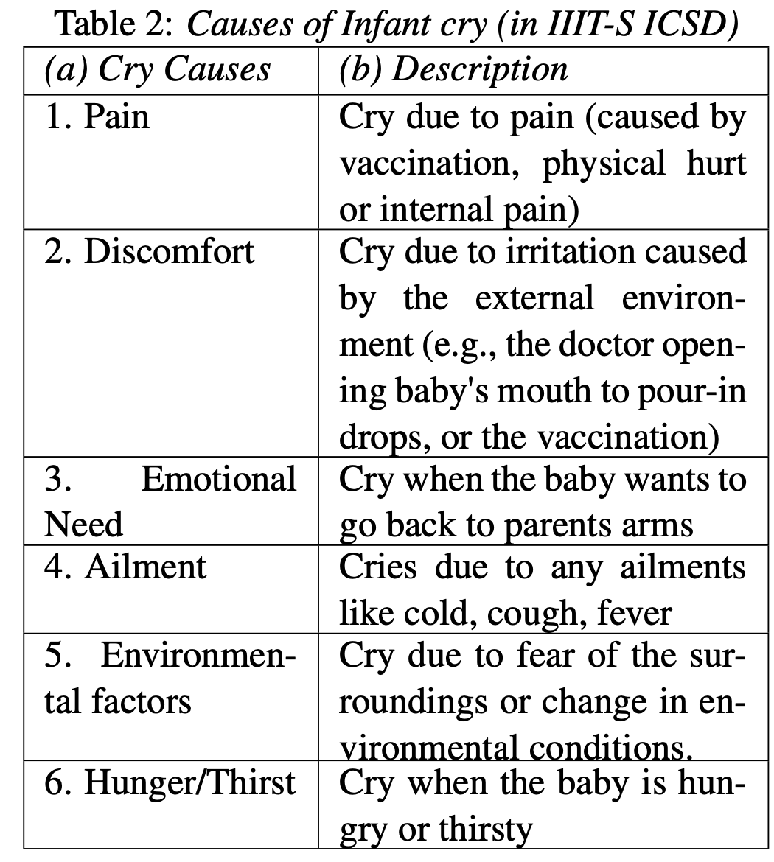](https://aclanthology.org/W15-5917.pdf)

Audio augmentation for all classes except for hungry

| Experiment name | Noise injection | Pitch shift | Shift time | speed |
| --- | --- | --- | --- | --- |
| gen1 | 0.003 | - | Both random | 0.65 |
| gen2 | 0.003 | - | Both random | 0.8 |
| gen3 | 0.003 | - | Both random | 1.1 |
| gen4 | 0.003 | 0.8 | Both random | Best of speed factor from the above Experiments |
| gen5 | 0.003 | 0.3 | Both random | Best of speed factor from the above Experiments |
| gen6 | 0.003 | 0.5 | Both random | Best of speed factor from the above Experiments |
| gen7 | 0.003 | 1 | Both random | Best of speed factor from the above Experiments |

| Hungry | is a response to the sucking reflex .thirsty or hungry |
| --- | --- |
| Normal | Most of the papers that use the Chillanto database make the prediction between asphixya and normal and consider normal as a healthy baby, so they merge "hunger, pain, and normal into one class called "normal,"  And some of them make a prediction between normal and deaf. |
| asphyxia | Asphyxia is a respiratory injury that leads to a serious damage for infants. |
| sleepy | based on the yawn reflex, indicating that baby is ready for sleep. |
| discomfort | A frequent reason for fussiness from a wet or dirty diaper/nappy, or from being too hot or too cold. it is based on a reflex that involves the skin, |
| Lower gas | produced in the lower stomach and is associated with gas and lower wind pain |
| pain | Just baby in pain, with no specific reason for that,  a paper said that they make the nurse performed heel prick test then record the pain cries. |
| Burp up | cry is produced by the chest constricting in an effort to force the wind up |